**COMPUTER SCIENCE DEPARTMENT**

LAB: Database System

**Lab Task # 01**

**Last date of Submission: 25th September 2024**

# Submitted To: Mam Kashia Riaz

**Student Name: UBAID-BIN-WARIS**

# Reg. Number: 2212416

# 

**Q no.1** Explore MySQL Workbench and explain in your own words.

MySQL is a tool for managing Databases. As we learn the Database System course we have to manage the databases in MySQL. MySQL Workbench is a tool to manage databases. It requires a strong a password to to connect to database because the data is the most precious thing the global world and we have to make sure the security of our database. After connecting the database we have seen the more and more databases in it. In my system I have 3 databases called **sakila**, **sys**, **world**. These are the sample examples provided by the MySQL Workbench. I Explore it one by one I have seen the Tables, Views, Functions in it and all the each and every database has these data. This data is also know as metadata and the actual data are save in the Tabels section.  
  
Althought, we have the Query section where we write queries to make operations on the database. And at the buttom of the workbench the output section were we see that the querie is succcessfull or not if not it shows errors. So that we started to write the basic SQL queries.

**Q no.2** Perform basic queries and show by screenshots along with output.

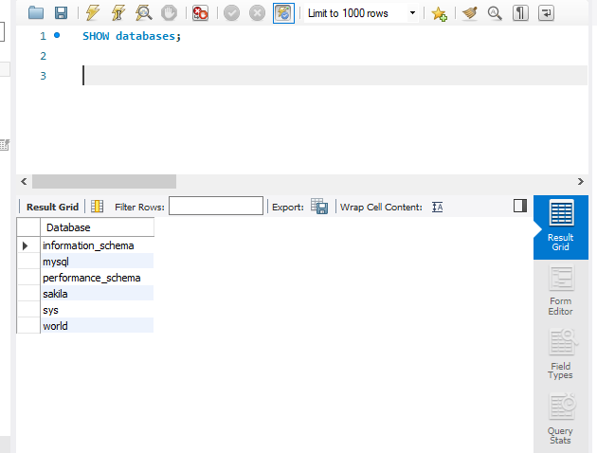

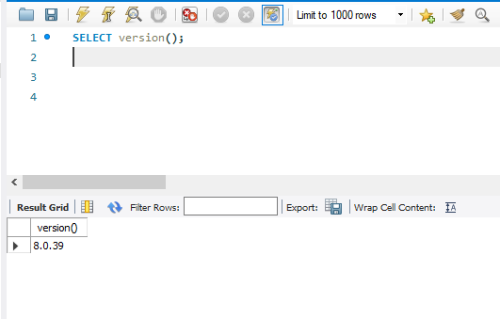

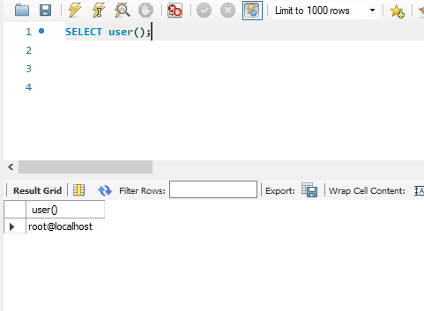

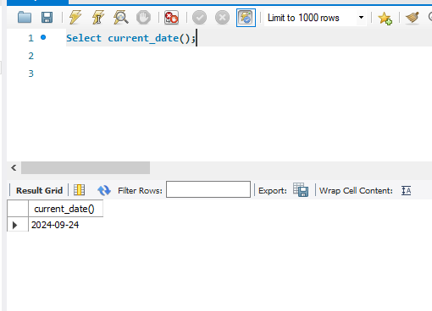

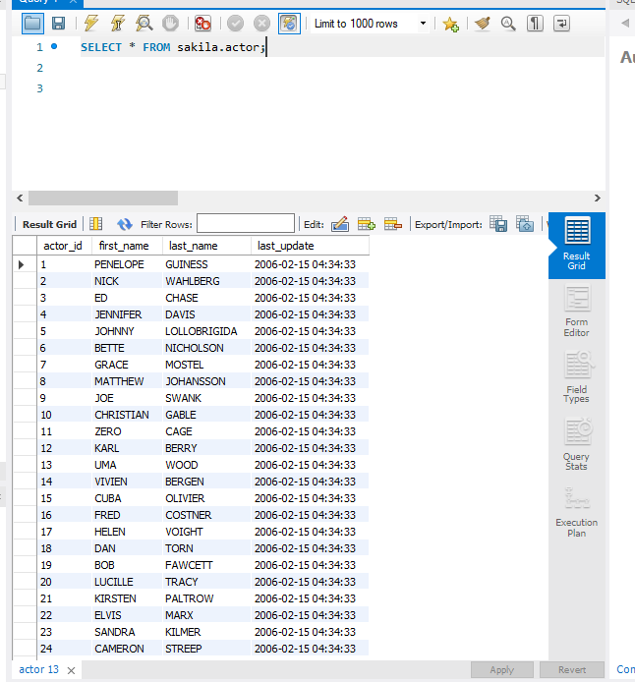

**Q no.3** Give 2 real life examples of every DBMS Architecture.

**1-Tier Architecture**

In a 1-tier architecture, the database is directly accessed by the user, with both the application and database residing on the same system. This is typically used in local environments.

* **Microsoft Access**: A local database used for small projects where the application and data are on the same machine.
* **SQLite in Mobile Apps**: A database stored directly on a mobile device, running within the same app.

**2-Tier Architecture**

In a 2-tier architecture, the database and the client interface are separated, with the client interacting with the database directly via a network.

* **Online Banking Systems**: Users interact with a client application that directly accesses the bank's central database.
* **Small Business ERP**: Client software connects directly to a central database for managing business operations.

**3-Tier Architecture**

In a 3-tier architecture, there is a middle layer (application server) between the client and the database. The client does not directly access the database but communicates through the middle layer.

* **E-commerce Websites (e.g., Amazon)**: Web browsers interact with application servers which retrieve data from the database.
* **Web-based Email (e.g., Gmail)**: Users interact with a web interface that communicates with backend servers and databases.

**Multi-Tier Architecture**

Multi-tier architecture is an extension of 3-tier architecture, where multiple layers are involved, such as load balancers, web servers, application servers, and database servers.

* **Social Media Platforms (e.g., Facebook)**: Multiple layers, including web, application, and database servers, handle millions of users and data.
* **Netflix**: Uses load balancers, web servers, and databases across multiple tiers to stream content and manage user data.